**LAPORAN PRAKTIKUM**

**BAHASA PEMROGRAMAN WEB 1**

(**DOSEN PENGAMPU : DEDE HUSEN., M.KOM)**



DISUSUN OLEH :

NAMA : MOHAMAD ABAN SY’BANA

NIM : 20230810012

KELAS : TINFC-2023-04

**TEKNIK INFORMATIKA**

**FAKULTAS ILMU KOMPUTER**

**UNIVERSITAS KUNINGAN**

**2024**

**Pre Test**

1. **Apa itu AWT?**

**Jawab** : AWT adalah toolkit yang digunakan untuk membuat aplikasi GUI di Java. AWT merupakan bagian dari Java Foundation Classes (JFC) yang menyediakan cara untuk membuat antarmuka pengguna yang kaya. Komponen AWT adalah "heavyweight," yang berarti mereka bergantung pada platform untuk menggambar dan berfungsi.

1. **Apa fungsi dari AWT?**

**Jawab :**

* Memungkinkan pengembang untuk membuat jendela, dialog, dan komponen lainnya untuk antarmuka pengguna.
* Menyediakan mekanisme untuk menangani berbagai jenis event seperti input pengguna (keyboard, mouse).
* Mengatur posisi dan ukuran komponen dalam jendela.
* Menggambar komponen GUI menggunakan sistem grafis yang disediakan oleh platform.

1. **Tuliskan contoh program sederhana untuk AWT?**

**Jawab :**

import java.awt.*;

public class aban extends Frame {

public static void main (String []args ){

aban test = new aban ();

}

public Praktikum1 (){

super("aban ");

setSize (400, 200);

Panel panelTombol = new Panel();

panelTombol.add(new Button ("Mulai"));

panelTombol.add(new Button ("Selesai"));

add("South", panelTombol);

show();

}

}

**Praktikum**

**Program 1**

import java.awt.*;

public class Praktikum1 extends Frame {

public static void main (String []args ){

Praktikum1 test = new Praktikum1();

}

public Praktikum1 (){

super("Praktikum1");

setSize (300, 100);

Panel panelTombol = new Panel();

panelTombol.add(new Button ("Mulai"));

panelTombol.add(new Button ("Selesai"));

add("South", panelTombol);

show();

}

}

**Hasil RUN**

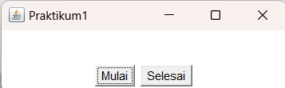

**Program 2**

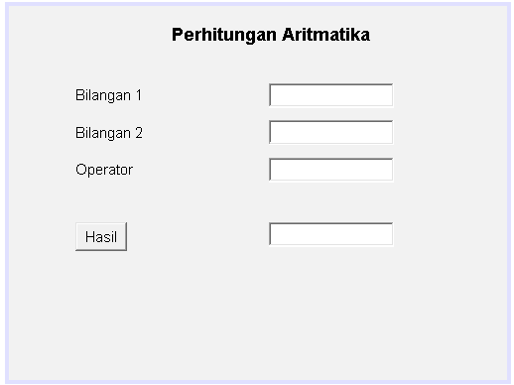

/*

* Click nbfs://nbhost/SystemFileSystem/Templates/Licenses/license-default.txt to change this license

* Click nbfs://nbhost/SystemFileSystem/Templates/GUIForms/JFrame.java to edit this template

*/

/**

*

* @author Suci Indah Lestari

*/

public class Praktikum1JF extends javax.swing.JFrame {

/**

* Creates new form Praktikum1JF

*/

public Praktikum1JF() {

initComponents();

}

/**

* This method is called from within the constructor to initialize the form.

* WARNING: Do NOT modify this code. The content of this method is always

* regenerated by the Form Editor.

*/

@SuppressWarnings("unchecked")

// <editor-fold defaultstate="collapsed" desc="Generated Code">

private void initComponents() {

label1 = new java.awt.Label();

label2 = new java.awt.Label();

label3 = new java.awt.Label();

label4 = new java.awt.Label();

textField1 = new java.awt.TextField();

textField2 = new java.awt.TextField();

textField3 = new java.awt.TextField();

button1 = new java.awt.Button();

textField4 = new java.awt.TextField();

setDefaultCloseOperation(javax.swing.WindowConstants.EXIT_ON_CLOSE);

label1.setFont(new java.awt.Font("Dialog", 1, 14)); // NOI18N

label1.setText("Perhitungan Aritmatika");

label2.setText("Bilangan 1");

label3.setText("Bilangan 2");

label4.setText("Operator");

button1.setLabel("Hasil");

button1.addMouseListener(new java.awt.event.MouseAdapter() {

public void mouseClicked(java.awt.event.MouseEvent evt) {

button1MouseClicked(evt);

}

});

javax.swing.GroupLayout layout = new javax.swing.GroupLayout(getContentPane());

getContentPane().setLayout(layout);

layout.setHorizontalGroup(

layout.createParallelGroup(javax.swing.GroupLayout.Alignment.LEADING)

.addGroup(javax.swing.GroupLayout.Alignment.TRAILING, layout.createSequentialGroup()

.addContainerGap(javax.swing.GroupLayout.DEFAULT_SIZE, Short.MAX_VALUE)

.addComponent(label1, javax.swing.GroupLayout.PREFERRED_SIZE, javax.swing.GroupLayout.DEFAULT_SIZE, javax.swing.GroupLayout.PREFERRED_SIZE)

.addGap(106, 106, 106))

.addGroup(layout.createSequentialGroup()

.addGap(53, 53, 53)

.addGroup(layout.createParallelGroup(javax.swing.GroupLayout.Alignment.LEADING)

.addComponent(label3, javax.swing.GroupLayout.PREFERRED_SIZE, 101, javax.swing.GroupLayout.PREFERRED_SIZE)

.addComponent(label4, javax.swing.GroupLayout.PREFERRED_SIZE, 101, javax.swing.GroupLayout.PREFERRED_SIZE)

.addComponent(label2, javax.swing.GroupLayout.PREFERRED_SIZE, 101, javax.swing.GroupLayout.PREFERRED_SIZE)

.addComponent(button1, javax.swing.GroupLayout.PREFERRED_SIZE, javax.swing.GroupLayout.DEFAULT_SIZE, javax.swing.GroupLayout.PREFERRED_SIZE))

.addGap(55, 55, 55)

.addGroup(layout.createParallelGroup(javax.swing.GroupLayout.Alignment.LEADING, false)

.addComponent(textField2, javax.swing.GroupLayout.DEFAULT_SIZE, javax.swing.GroupLayout.DEFAULT_SIZE, Short.MAX_VALUE)

.addComponent(textField1, javax.swing.GroupLayout.DEFAULT_SIZE, javax.swing.GroupLayout.DEFAULT_SIZE, Short.MAX_VALUE)

.addComponent(textField4, javax.swing.GroupLayout.DEFAULT_SIZE, javax.swing.GroupLayout.DEFAULT_SIZE, Short.MAX_VALUE)

.addComponent(textField3, javax.swing.GroupLayout.PREFERRED_SIZE, 101, javax.swing.GroupLayout.PREFERRED_SIZE))

.addContainerGap(90, Short.MAX_VALUE))

);

layout.setVerticalGroup(

layout.createParallelGroup(javax.swing.GroupLayout.Alignment.LEADING)

.addGroup(layout.createSequentialGroup()

.addContainerGap()

.addComponent(label1, javax.swing.GroupLayout.PREFERRED_SIZE, javax.swing.GroupLayout.DEFAULT_SIZE, javax.swing.GroupLayout.PREFERRED_SIZE)

.addGap(28, 28, 28)

.addGroup(layout.createParallelGroup(javax.swing.GroupLayout.Alignment.LEADING)

.addComponent(label2, javax.swing.GroupLayout.PREFERRED_SIZE, javax.swing.GroupLayout.DEFAULT_SIZE, javax.swing.GroupLayout.PREFERRED_SIZE)

.addComponent(textField1, javax.swing.GroupLayout.PREFERRED_SIZE, javax.swing.GroupLayout.DEFAULT_SIZE, javax.swing.GroupLayout.PREFERRED_SIZE))

.addPreferredGap(javax.swing.LayoutStyle.ComponentPlacement.RELATED)

.addGroup(layout.createParallelGroup(javax.swing.GroupLayout.Alignment.LEADING)

.addComponent(label3, javax.swing.GroupLayout.PREFERRED_SIZE, javax.swing.GroupLayout.DEFAULT_SIZE, javax.swing.GroupLayout.PREFERRED_SIZE)

.addComponent(textField2, javax.swing.GroupLayout.PREFERRED_SIZE, javax.swing.GroupLayout.DEFAULT_SIZE, javax.swing.GroupLayout.PREFERRED_SIZE))

.addPreferredGap(javax.swing.LayoutStyle.ComponentPlacement.RELATED)

.addGroup(layout.createParallelGroup(javax.swing.GroupLayout.Alignment.LEADING)

.addComponent(label4, javax.swing.GroupLayout.PREFERRED_SIZE, javax.swing.GroupLayout.DEFAULT_SIZE, javax.swing.GroupLayout.PREFERRED_SIZE)

.addComponent(textField3, javax.swing.GroupLayout.PREFERRED_SIZE, javax.swing.GroupLayout.DEFAULT_SIZE, javax.swing.GroupLayout.PREFERRED_SIZE))

.addGap(32, 32, 32)

.addGroup(layout.createParallelGroup(javax.swing.GroupLayout.Alignment.LEADING)

.addComponent(button1, javax.swing.GroupLayout.PREFERRED_SIZE, javax.swing.GroupLayout.DEFAULT_SIZE, javax.swing.GroupLayout.PREFERRED_SIZE)

.addComponent(textField4, javax.swing.GroupLayout.PREFERRED_SIZE, javax.swing.GroupLayout.DEFAULT_SIZE, javax.swing.GroupLayout.PREFERRED_SIZE))

.addContainerGap(103, Short.MAX_VALUE))

);

pack();

}// </editor-fold>

private void button1MouseClicked(java.awt.event.MouseEvent evt) {

// TODO add your handling code here:

int bil1, bil2, hasil;

bil1 = Integer.parseInt(textField1.getText());

bil2 = Integer.parseInt(textField2.getText());

if (textField3.getText().equals("+")){

hasil = bil1 + bil2;

textField4.setText(String.valueOf(hasil));

}

else if (textField3.getText().equals("-")){

hasil = bil1 - bil2;

textField4.setText(String.valueOf(hasil));

}

else if (textField3.getText().equals("*")){

hasil = bil1 * bil2;

textField4.setText(String.valueOf(hasil));

}

else if (textField3.getText().equals("/")){

hasil = bil1 / bil2;

textField4.setText(String.valueOf(hasil));

}

}

/**

* @param args the command line arguments

*/

public static void main(String args[]) {

/* Set the Nimbus look and feel */

//<editor-fold defaultstate="collapsed" desc=" Look and feel setting code (optional) ">

/* If Nimbus (introduced in Java SE 6) is not available, stay with the default look and feel.

* For details see http://download.oracle.com/javase/tutorial/uiswing/lookandfeel/plaf.html

*/

try {

for (javax.swing.UIManager.LookAndFeelInfo info : javax.swing.UIManager.getInstalledLookAndFeels()) {

if ("Nimbus".equals(info.getName())) {

javax.swing.UIManager.setLookAndFeel(info.getClassName());

break;

}

}

} catch (ClassNotFoundException ex) {

java.util.logging.Logger.getLogger(Praktikum1JF.class.getName()).log(java.util.logging.Level.SEVERE, null, ex);

} catch (InstantiationException ex) {

java.util.logging.Logger.getLogger(Praktikum1JF.class.getName()).log(java.util.logging.Level.SEVERE, null, ex);

} catch (IllegalAccessException ex) {

java.util.logging.Logger.getLogger(Praktikum1JF.class.getName()).log(java.util.logging.Level.SEVERE, null, ex);

} catch (javax.swing.UnsupportedLookAndFeelException ex) {

java.util.logging.Logger.getLogger(Praktikum1JF.class.getName()).log(java.util.logging.Level.SEVERE, null, ex);

}

//</editor-fold>

/* Create and display the form */

java.awt.EventQueue.invokeLater(new Runnable() {

public void run() {

new Praktikum1JF().setVisible(true);

}

});

}

// Variables declaration - do not modify

private java.awt.Button button1;

private java.awt.Label label1;

private java.awt.Label label2;

private java.awt.Label label3;

private java.awt.Label label4;

private java.awt.TextField textField1;

private java.awt.TextField textField2;

private java.awt.TextField textField3;

private java.awt.TextField textField4;

// End of variables declaration

}

**Hasil RUN**

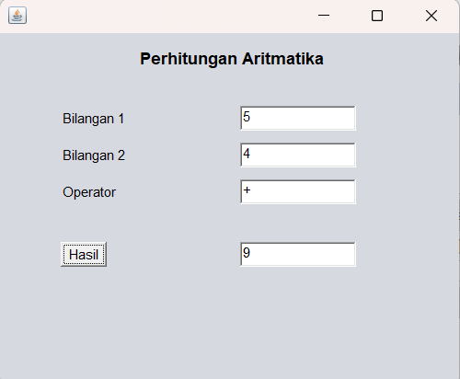

**Post Test**

1. Buat java class baru dengan nama BP1_M1_PostTest_NamaAnda. Buat program untuk menghasilkan kalkulator.

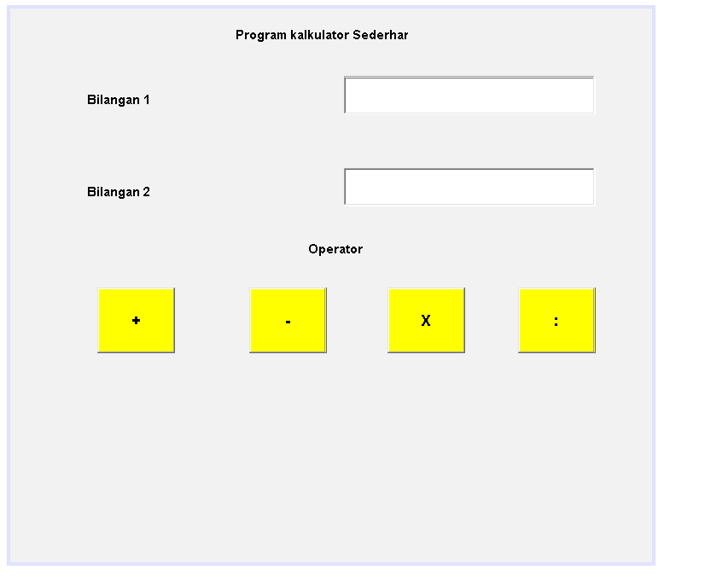

**Code**

/*

* Click nbfs://nbhost/SystemFileSystem/Templates/Licenses/license-default.txt to change this license

* Click nbfs://nbhost/SystemFileSystem/Templates/GUIForms/JFrame.java to edit this template

*/

package com.mycompany.praktikum_m1;

/**

*

* @author Suci Indah Lestari

*/

public class postes_m1 extends javax.swing.JFrame {

/**

* Creates new form postes_m1

*/

public postes_m1() {

initComponents();

}

/**

* This method is called from within the constructor to initialize the form.

* WARNING: Do NOT modify this code. The content of this method is always

* regenerated by the Form Editor.

*/

@SuppressWarnings("unchecked")

// <editor-fold defaultstate="collapsed" desc="Generated Code">

private void initComponents() {

label1 = new java.awt.Label();

label2 = new java.awt.Label();

label3 = new java.awt.Label();

textField1 = new java.awt.TextField();

textField2 = new java.awt.TextField();

button1 = new java.awt.Button();

button2 = new java.awt.Button();

button3 = new java.awt.Button();

button4 = new java.awt.Button();

label4 = new java.awt.Label();

textField3 = new java.awt.TextField();

label5 = new java.awt.Label();

setDefaultCloseOperation(javax.swing.WindowConstants.EXIT_ON_CLOSE);

label1.setFont(new java.awt.Font("Dialog", 1, 12)); // NOI18N

label1.setText("Program kalkulator Sederhana");

label2.setFont(new java.awt.Font("Dialog", 1, 12)); // NOI18N

label2.setText("Bilangan 2");

label3.setFont(new java.awt.Font("Dialog", 1, 12)); // NOI18N

label3.setText("Bilangan 1");

button1.setBackground(new java.awt.Color(255, 255, 0));

button1.setFont(new java.awt.Font("Dialog", 1, 14)); // NOI18N

button1.setLabel("-");

button1.addMouseListener(new java.awt.event.MouseAdapter() {

public void mouseClicked(java.awt.event.MouseEvent evt) {

button1MouseClicked(evt);

}

});

button1.addActionListener(new java.awt.event.ActionListener() {

public void actionPerformed(java.awt.event.ActionEvent evt) {

button1ActionPerformed(evt);

}

});

button2.setBackground(new java.awt.Color(255, 255, 0));

button2.setFont(new java.awt.Font("Dialog", 1, 14)); // NOI18N

button2.setLabel("+");

button2.addMouseListener(new java.awt.event.MouseAdapter() {

public void mouseClicked(java.awt.event.MouseEvent evt) {

button2MouseClicked(evt);

}

});

button3.setBackground(new java.awt.Color(255, 255, 0));

button3.setFont(new java.awt.Font("Dialog", 1, 14)); // NOI18N

button3.setLabel(":");

button3.addMouseListener(new java.awt.event.MouseAdapter() {

public void mouseClicked(java.awt.event.MouseEvent evt) {

button3MouseClicked(evt);

}

});

button4.setBackground(new java.awt.Color(255, 255, 0));

button4.setFont(new java.awt.Font("Dialog", 1, 14)); // NOI18N

button4.setLabel("X");

button4.addMouseListener(new java.awt.event.MouseAdapter() {

public void mouseClicked(java.awt.event.MouseEvent evt) {

button4MouseClicked(evt);

}

});

label4.setFont(new java.awt.Font("Dialog", 1, 12)); // NOI18N

label4.setText("Operator");

label5.setFont(new java.awt.Font("Dialog", 1, 12)); // NOI18N

label5.setText("Hasil");

javax.swing.GroupLayout layout = new javax.swing.GroupLayout(getContentPane());

getContentPane().setLayout(layout);

layout.setHorizontalGroup(

layout.createParallelGroup(javax.swing.GroupLayout.Alignment.LEADING)

.addGroup(javax.swing.GroupLayout.Alignment.TRAILING, layout.createSequentialGroup()

.addGroup(layout.createParallelGroup(javax.swing.GroupLayout.Alignment.TRAILING)

.addGroup(javax.swing.GroupLayout.Alignment.LEADING, layout.createSequentialGroup()

.addGap(210, 210, 210)

.addComponent(label1, javax.swing.GroupLayout.PREFERRED_SIZE, 162, javax.swing.GroupLayout.PREFERRED_SIZE)

.addGap(0, 0, Short.MAX_VALUE))

.addGroup(javax.swing.GroupLayout.Alignment.LEADING, layout.createSequentialGroup()

.addGap(71, 71, 71)

.addGroup(layout.createParallelGroup(javax.swing.GroupLayout.Alignment.LEADING)

.addGroup(layout.createSequentialGroup()

.addComponent(label3, javax.swing.GroupLayout.PREFERRED_SIZE, 162, javax.swing.GroupLayout.PREFERRED_SIZE)

.addPreferredGap(javax.swing.LayoutStyle.ComponentPlacement.RELATED, javax.swing.GroupLayout.DEFAULT_SIZE, Short.MAX_VALUE)

.addComponent(textField2, javax.swing.GroupLayout.PREFERRED_SIZE, 236, javax.swing.GroupLayout.PREFERRED_SIZE))

.addGroup(layout.createSequentialGroup()

.addComponent(label2, javax.swing.GroupLayout.PREFERRED_SIZE, 162, javax.swing.GroupLayout.PREFERRED_SIZE)

.addPreferredGap(javax.swing.LayoutStyle.ComponentPlacement.RELATED, javax.swing.GroupLayout.DEFAULT_SIZE, Short.MAX_VALUE)

.addComponent(textField1, javax.swing.GroupLayout.PREFERRED_SIZE, 236, javax.swing.GroupLayout.PREFERRED_SIZE))

.addGroup(layout.createSequentialGroup()

.addGap(10, 10, 10)

.addGroup(layout.createParallelGroup(javax.swing.GroupLayout.Alignment.LEADING)

.addGroup(layout.createSequentialGroup()

.addComponent(button2, javax.swing.GroupLayout.PREFERRED_SIZE, 73, javax.swing.GroupLayout.PREFERRED_SIZE)

.addPreferredGap(javax.swing.LayoutStyle.ComponentPlacement.RELATED, 69, Short.MAX_VALUE)

.addComponent(button1, javax.swing.GroupLayout.PREFERRED_SIZE, 73, javax.swing.GroupLayout.PREFERRED_SIZE)

.addGap(57, 57, 57)

.addComponent(button4, javax.swing.GroupLayout.PREFERRED_SIZE, 73, javax.swing.GroupLayout.PREFERRED_SIZE)

.addGap(49, 49, 49)

.addComponent(button3, javax.swing.GroupLayout.PREFERRED_SIZE, 73, javax.swing.GroupLayout.PREFERRED_SIZE))

.addGroup(layout.createSequentialGroup()

.addComponent(label5, javax.swing.GroupLayout.PREFERRED_SIZE, 162, javax.swing.GroupLayout.PREFERRED_SIZE)

.addPreferredGap(javax.swing.LayoutStyle.ComponentPlacement.RELATED, javax.swing.GroupLayout.DEFAULT_SIZE, Short.MAX_VALUE)

.addComponent(textField3, javax.swing.GroupLayout.PREFERRED_SIZE, 236, javax.swing.GroupLayout.PREFERRED_SIZE)))))))

.addGap(52, 52, 52))

.addGroup(javax.swing.GroupLayout.Alignment.TRAILING, layout.createSequentialGroup()

.addGap(0, 0, Short.MAX_VALUE)

.addComponent(label4, javax.swing.GroupLayout.PREFERRED_SIZE, 162, javax.swing.GroupLayout.PREFERRED_SIZE)

.addGap(160, 160, 160))

);

layout.setVerticalGroup(

layout.createParallelGroup(javax.swing.GroupLayout.Alignment.LEADING)

.addGroup(layout.createSequentialGroup()

.addContainerGap()

.addComponent(label1, javax.swing.GroupLayout.PREFERRED_SIZE, 28, javax.swing.GroupLayout.PREFERRED_SIZE)

.addGap(25, 25, 25)

.addGroup(layout.createParallelGroup(javax.swing.GroupLayout.Alignment.TRAILING)

.addComponent(label3, javax.swing.GroupLayout.PREFERRED_SIZE, 28, javax.swing.GroupLayout.PREFERRED_SIZE)

.addComponent(textField2, javax.swing.GroupLayout.PREFERRED_SIZE, 36, javax.swing.GroupLayout.PREFERRED_SIZE))

.addGap(50, 50, 50)

.addGroup(layout.createParallelGroup(javax.swing.GroupLayout.Alignment.LEADING)

.addComponent(label2, javax.swing.GroupLayout.Alignment.TRAILING, javax.swing.GroupLayout.PREFERRED_SIZE, 28, javax.swing.GroupLayout.PREFERRED_SIZE)

.addComponent(textField1, javax.swing.GroupLayout.Alignment.TRAILING, javax.swing.GroupLayout.PREFERRED_SIZE, 36, javax.swing.GroupLayout.PREFERRED_SIZE))

.addGap(26, 26, 26)

.addComponent(label4, javax.swing.GroupLayout.PREFERRED_SIZE, 28, javax.swing.GroupLayout.PREFERRED_SIZE)

.addGap(22, 22, 22)

.addGroup(layout.createParallelGroup(javax.swing.GroupLayout.Alignment.LEADING)

.addGroup(layout.createSequentialGroup()

.addGroup(layout.createParallelGroup(javax.swing.GroupLayout.Alignment.LEADING)

.addComponent(button4, javax.swing.GroupLayout.PREFERRED_SIZE, 62, javax.swing.GroupLayout.PREFERRED_SIZE)

.addComponent(button1, javax.swing.GroupLayout.PREFERRED_SIZE, 62, javax.swing.GroupLayout.PREFERRED_SIZE)

.addComponent(button3, javax.swing.GroupLayout.PREFERRED_SIZE, 62, javax.swing.GroupLayout.PREFERRED_SIZE))

.addPreferredGap(javax.swing.LayoutStyle.ComponentPlacement.RELATED, 48, Short.MAX_VALUE)

.addGroup(layout.createParallelGroup(javax.swing.GroupLayout.Alignment.LEADING)

.addComponent(textField3, javax.swing.GroupLayout.PREFERRED_SIZE, 36, javax.swing.GroupLayout.PREFERRED_SIZE)

.addComponent(label5, javax.swing.GroupLayout.PREFERRED_SIZE, 28, javax.swing.GroupLayout.PREFERRED_SIZE))

.addGap(111, 111, 111))

.addGroup(layout.createSequentialGroup()

.addComponent(button2, javax.swing.GroupLayout.PREFERRED_SIZE, 62, javax.swing.GroupLayout.PREFERRED_SIZE)

.addContainerGap(javax.swing.GroupLayout.DEFAULT_SIZE, Short.MAX_VALUE))))

);

pack();

}// </editor-fold>

private void button2MouseClicked(java.awt.event.MouseEvent evt) {

// TODO add your handling code here:

int bil1, bil2, hasil;

bil1 = Integer.parseInt(textField1.getText());

bil2 = Integer.parseInt(textField2.getText());

hasil = bil1 + bil2;

textField3.setText(String.valueOf(hasil));

}

private void button1ActionPerformed(java.awt.event.ActionEvent evt) {

// TODO add your handling code here:

}

private void button1MouseClicked(java.awt.event.MouseEvent evt) {

// TODO add your handling code here:

int bil1, bil2, hasil;

bil1 = Integer.parseInt(textField1.getText());

bil2 = Integer.parseInt(textField2.getText());

hasil = bil1 - bil2;

textField3.setText(String.valueOf(hasil));

}

private void button4MouseClicked(java.awt.event.MouseEvent evt) {

// TODO add your handling code here:

int bil1, bil2, hasil;

bil1 = Integer.parseInt(textField1.getText());

bil2 = Integer.parseInt(textField2.getText());

hasil = bil1 * bil2;

textField3.setText(String.valueOf(hasil));

}

private void button3MouseClicked(java.awt.event.MouseEvent evt) {

// TODO add your handling code here:

double bil1, bil2, hasil;

bil1 = Double.parseDouble(textField1.getText());

bil2 = Double.parseDouble(textField2.getText());

hasil = bil1 / bil2;

textField3.setText(String.valueOf(hasil));

}

/**

* @param args the command line arguments

*/

public static void main(String args[]) {

/* Set the Nimbus look and feel */

//<editor-fold defaultstate="collapsed" desc=" Look and feel setting code (optional) ">

/* If Nimbus (introduced in Java SE 6) is not available, stay with the default look and feel.

* For details see http://download.oracle.com/javase/tutorial/uiswing/lookandfeel/plaf.html

*/

try {

for (javax.swing.UIManager.LookAndFeelInfo info : javax.swing.UIManager.getInstalledLookAndFeels()) {

if ("Nimbus".equals(info.getName())) {

javax.swing.UIManager.setLookAndFeel(info.getClassName());

break;

}

}

} catch (ClassNotFoundException ex) {

java.util.logging.Logger.getLogger(postes_m1.class.getName()).log(java.util.logging.Level.SEVERE, null, ex);

} catch (InstantiationException ex) {

java.util.logging.Logger.getLogger(postes_m1.class.getName()).log(java.util.logging.Level.SEVERE, null, ex);

} catch (IllegalAccessException ex) {

java.util.logging.Logger.getLogger(postes_m1.class.getName()).log(java.util.logging.Level.SEVERE, null, ex);

} catch (javax.swing.UnsupportedLookAndFeelException ex) {

java.util.logging.Logger.getLogger(postes_m1.class.getName()).log(java.util.logging.Level.SEVERE, null, ex);

}

//</editor-fold>

/* Create and display the form */

java.awt.EventQueue.invokeLater(new Runnable() {

public void run() {

new postes_m1().setVisible(true);

}

});

}

// Variables declaration - do not modify

private java.awt.Button button1;

private java.awt.Button button2;

private java.awt.Button button3;

private java.awt.Button button4;

private java.awt.Label label1;

private java.awt.Label label2;

private java.awt.Label label3;

private java.awt.Label label4;

private java.awt.Label label5;

private java.awt.TextField textField1;

private java.awt.TextField textField2;

private java.awt.TextField textField3;

// End of variables declaration

}

**Hasil Run**

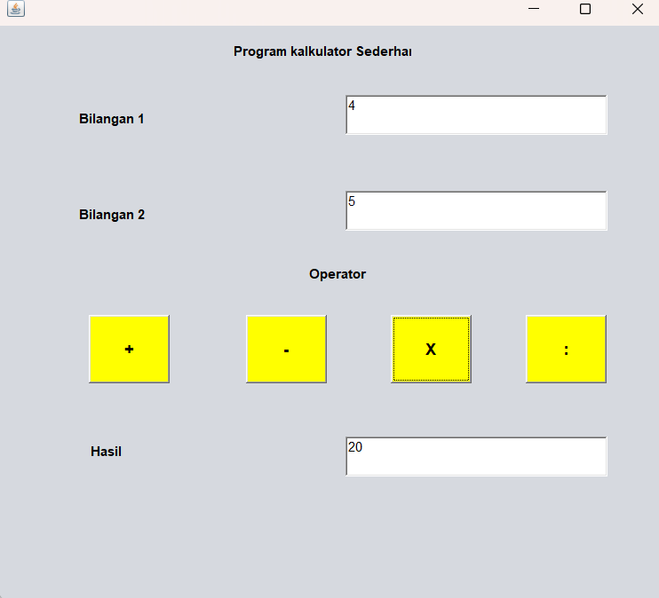

**Tugas**

1. Buat java class baru dengan nama BP1_M1_Tugas_NamaAnda. Buat program dengan menggunakan GUI AWT untuk menyelesaikan permasalahan pada tugas M1 (BP1_M1_Tugas_NamaAnda).

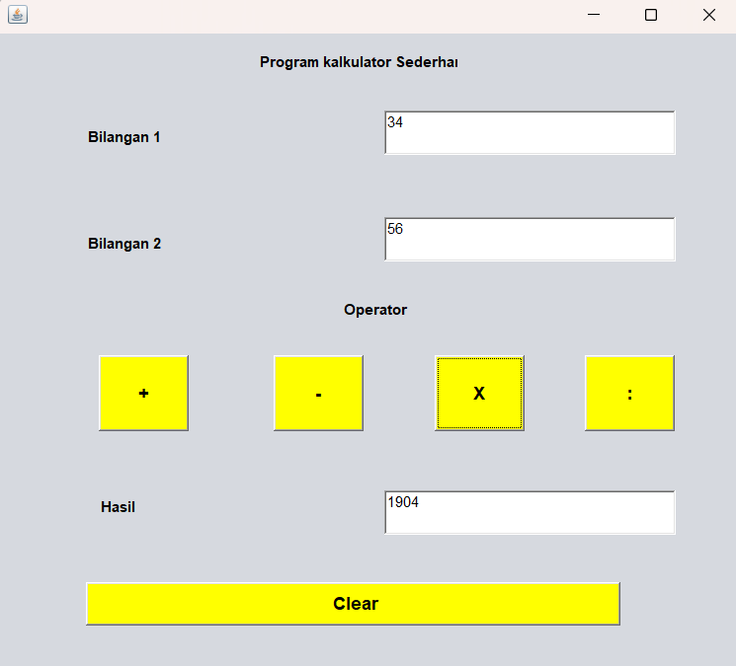

/*

* Click nbfs://nbhost/SystemFileSystem/Templates/Licenses/license-default.txt to change this license

* Click nbfs://nbhost/SystemFileSystem/Templates/GUIForms/JFrame.java to edit this template

*/

package com.mycompany.praktikum_m1;

/**

*

* @author Suci Indah Lestari

*/

public class postes_m1 extends javax.swing.JFrame {

/**

* Creates new form postes_m1

*/

public postes_m1() {

initComponents();

}

/**

* This method is called from within the constructor to initialize the form.

* WARNING: Do NOT modify this code. The content of this method is always

* regenerated by the Form Editor.

*/

@SuppressWarnings("unchecked")

// <editor-fold defaultstate="collapsed" desc="Generated Code">

private void initComponents() {

label1 = new java.awt.Label();

label2 = new java.awt.Label();

label3 = new java.awt.Label();

textField1 = new java.awt.TextField();

textField2 = new java.awt.TextField();

button1 = new java.awt.Button();

button2 = new java.awt.Button();

button3 = new java.awt.Button();

button4 = new java.awt.Button();

label4 = new java.awt.Label();

textField3 = new java.awt.TextField();

label5 = new java.awt.Label();

button5 = new java.awt.Button();

setDefaultCloseOperation(javax.swing.WindowConstants.EXIT_ON_CLOSE);

label1.setFont(new java.awt.Font("Dialog", 1, 12)); // NOI18N

label1.setText("Program kalkulator Sederhana");

label2.setFont(new java.awt.Font("Dialog", 1, 12)); // NOI18N

label2.setText("Bilangan 2");

label3.setFont(new java.awt.Font("Dialog", 1, 12)); // NOI18N

label3.setText("Bilangan 1");

button1.setBackground(new java.awt.Color(255, 255, 0));

button1.setFont(new java.awt.Font("Dialog", 1, 14)); // NOI18N

button1.setLabel("-");

button1.addMouseListener(new java.awt.event.MouseAdapter() {

public void mouseClicked(java.awt.event.MouseEvent evt) {

button1MouseClicked(evt);

}

});

button1.addActionListener(new java.awt.event.ActionListener() {

public void actionPerformed(java.awt.event.ActionEvent evt) {

button1ActionPerformed(evt);

}

});

button2.setBackground(new java.awt.Color(255, 255, 0));

button2.setFont(new java.awt.Font("Dialog", 1, 14)); // NOI18N

button2.setLabel("+");

button2.addMouseListener(new java.awt.event.MouseAdapter() {

public void mouseClicked(java.awt.event.MouseEvent evt) {

button2MouseClicked(evt);

}

});

button3.setBackground(new java.awt.Color(255, 255, 0));

button3.setFont(new java.awt.Font("Dialog", 1, 14)); // NOI18N

button3.setLabel(":");

button3.addMouseListener(new java.awt.event.MouseAdapter() {

public void mouseClicked(java.awt.event.MouseEvent evt) {

button3MouseClicked(evt);

}

});

button4.setBackground(new java.awt.Color(255, 255, 0));

button4.setFont(new java.awt.Font("Dialog", 1, 14)); // NOI18N

button4.setLabel("X");

button4.addMouseListener(new java.awt.event.MouseAdapter() {

public void mouseClicked(java.awt.event.MouseEvent evt) {

button4MouseClicked(evt);

}

});

label4.setFont(new java.awt.Font("Dialog", 1, 12)); // NOI18N

label4.setText("Operator");

label5.setFont(new java.awt.Font("Dialog", 1, 12)); // NOI18N

label5.setText("Hasil");

button5.setBackground(new java.awt.Color(255, 255, 0));

button5.setFont(new java.awt.Font("Dialog", 1, 14)); // NOI18N

button5.setLabel(" Clear");

button5.addMouseListener(new java.awt.event.MouseAdapter() {

public void mouseEntered(java.awt.event.MouseEvent evt) {

button5MouseEntered(evt);

}

});

button5.addActionListener(new java.awt.event.ActionListener() {

public void actionPerformed(java.awt.event.ActionEvent evt) {

button5ActionPerformed(evt);

}

});

javax.swing.GroupLayout layout = new javax.swing.GroupLayout(getContentPane());

getContentPane().setLayout(layout);

layout.setHorizontalGroup(

layout.createParallelGroup(javax.swing.GroupLayout.Alignment.LEADING)

.addGroup(javax.swing.GroupLayout.Alignment.TRAILING, layout.createSequentialGroup()

.addGroup(layout.createParallelGroup(javax.swing.GroupLayout.Alignment.TRAILING)

.addGroup(javax.swing.GroupLayout.Alignment.LEADING, layout.createSequentialGroup()

.addGap(210, 210, 210)

.addComponent(label1, javax.swing.GroupLayout.PREFERRED_SIZE, 162, javax.swing.GroupLayout.PREFERRED_SIZE)

.addGap(0, 0, Short.MAX_VALUE))

.addGroup(javax.swing.GroupLayout.Alignment.LEADING, layout.createSequentialGroup()

.addGap(71, 71, 71)

.addGroup(layout.createParallelGroup(javax.swing.GroupLayout.Alignment.LEADING)

.addGroup(layout.createSequentialGroup()

.addComponent(button5, javax.swing.GroupLayout.PREFERRED_SIZE, 433, javax.swing.GroupLayout.PREFERRED_SIZE)

.addGap(0, 44, Short.MAX_VALUE))

.addGroup(layout.createSequentialGroup()

.addComponent(label3, javax.swing.GroupLayout.PREFERRED_SIZE, 162, javax.swing.GroupLayout.PREFERRED_SIZE)

.addPreferredGap(javax.swing.LayoutStyle.ComponentPlacement.RELATED, javax.swing.GroupLayout.DEFAULT_SIZE, Short.MAX_VALUE)

.addComponent(textField2, javax.swing.GroupLayout.PREFERRED_SIZE, 236, javax.swing.GroupLayout.PREFERRED_SIZE))

.addGroup(layout.createSequentialGroup()

.addComponent(label2, javax.swing.GroupLayout.PREFERRED_SIZE, 162, javax.swing.GroupLayout.PREFERRED_SIZE)

.addPreferredGap(javax.swing.LayoutStyle.ComponentPlacement.RELATED, javax.swing.GroupLayout.DEFAULT_SIZE, Short.MAX_VALUE)

.addComponent(textField1, javax.swing.GroupLayout.PREFERRED_SIZE, 236, javax.swing.GroupLayout.PREFERRED_SIZE))

.addGroup(layout.createSequentialGroup()

.addGap(10, 10, 10)

.addGroup(layout.createParallelGroup(javax.swing.GroupLayout.Alignment.LEADING)

.addGroup(layout.createSequentialGroup()

.addComponent(button2, javax.swing.GroupLayout.PREFERRED_SIZE, 73, javax.swing.GroupLayout.PREFERRED_SIZE)

.addPreferredGap(javax.swing.LayoutStyle.ComponentPlacement.RELATED, javax.swing.GroupLayout.DEFAULT_SIZE, Short.MAX_VALUE)

.addComponent(button1, javax.swing.GroupLayout.PREFERRED_SIZE, 73, javax.swing.GroupLayout.PREFERRED_SIZE)

.addGap(57, 57, 57)

.addComponent(button4, javax.swing.GroupLayout.PREFERRED_SIZE, 73, javax.swing.GroupLayout.PREFERRED_SIZE)

.addGap(49, 49, 49)

.addComponent(button3, javax.swing.GroupLayout.PREFERRED_SIZE, 73, javax.swing.GroupLayout.PREFERRED_SIZE))

.addGroup(layout.createSequentialGroup()

.addComponent(label5, javax.swing.GroupLayout.PREFERRED_SIZE, 162, javax.swing.GroupLayout.PREFERRED_SIZE)

.addPreferredGap(javax.swing.LayoutStyle.ComponentPlacement.RELATED, javax.swing.GroupLayout.DEFAULT_SIZE, Short.MAX_VALUE)

.addComponent(textField3, javax.swing.GroupLayout.PREFERRED_SIZE, 236, javax.swing.GroupLayout.PREFERRED_SIZE)))))))

.addGap(52, 52, 52))

.addGroup(javax.swing.GroupLayout.Alignment.TRAILING, layout.createSequentialGroup()

.addGap(0, 0, Short.MAX_VALUE)

.addComponent(label4, javax.swing.GroupLayout.PREFERRED_SIZE, 162, javax.swing.GroupLayout.PREFERRED_SIZE)

.addGap(160, 160, 160))

);

layout.setVerticalGroup(

layout.createParallelGroup(javax.swing.GroupLayout.Alignment.LEADING)

.addGroup(layout.createSequentialGroup()

.addContainerGap()

.addComponent(label1, javax.swing.GroupLayout.PREFERRED_SIZE, 28, javax.swing.GroupLayout.PREFERRED_SIZE)

.addGap(25, 25, 25)

.addGroup(layout.createParallelGroup(javax.swing.GroupLayout.Alignment.TRAILING)

.addComponent(label3, javax.swing.GroupLayout.PREFERRED_SIZE, 28, javax.swing.GroupLayout.PREFERRED_SIZE)

.addComponent(textField2, javax.swing.GroupLayout.PREFERRED_SIZE, 36, javax.swing.GroupLayout.PREFERRED_SIZE))

.addGap(50, 50, 50)

.addGroup(layout.createParallelGroup(javax.swing.GroupLayout.Alignment.LEADING)

.addComponent(label2, javax.swing.GroupLayout.Alignment.TRAILING, javax.swing.GroupLayout.PREFERRED_SIZE, 28, javax.swing.GroupLayout.PREFERRED_SIZE)

.addComponent(textField1, javax.swing.GroupLayout.Alignment.TRAILING, javax.swing.GroupLayout.PREFERRED_SIZE, 36, javax.swing.GroupLayout.PREFERRED_SIZE))

.addGap(26, 26, 26)

.addComponent(label4, javax.swing.GroupLayout.PREFERRED_SIZE, 28, javax.swing.GroupLayout.PREFERRED_SIZE)

.addGap(22, 22, 22)

.addGroup(layout.createParallelGroup(javax.swing.GroupLayout.Alignment.LEADING)

.addGroup(layout.createSequentialGroup()

.addGroup(layout.createParallelGroup(javax.swing.GroupLayout.Alignment.LEADING)

.addComponent(button4, javax.swing.GroupLayout.PREFERRED_SIZE, 62, javax.swing.GroupLayout.PREFERRED_SIZE)

.addComponent(button1, javax.swing.GroupLayout.PREFERRED_SIZE, 62, javax.swing.GroupLayout.PREFERRED_SIZE)

.addComponent(button3, javax.swing.GroupLayout.PREFERRED_SIZE, 62, javax.swing.GroupLayout.PREFERRED_SIZE))

.addPreferredGap(javax.swing.LayoutStyle.ComponentPlacement.RELATED, 48, Short.MAX_VALUE)

.addGroup(layout.createParallelGroup(javax.swing.GroupLayout.Alignment.LEADING)

.addComponent(textField3, javax.swing.GroupLayout.PREFERRED_SIZE, 36, javax.swing.GroupLayout.PREFERRED_SIZE)

.addComponent(label5, javax.swing.GroupLayout.PREFERRED_SIZE, 28, javax.swing.GroupLayout.PREFERRED_SIZE))

.addGap(38, 38, 38))

.addGroup(layout.createSequentialGroup()

.addComponent(button2, javax.swing.GroupLayout.PREFERRED_SIZE, 62, javax.swing.GroupLayout.PREFERRED_SIZE)

.addPreferredGap(javax.swing.LayoutStyle.ComponentPlacement.RELATED, javax.swing.GroupLayout.DEFAULT_SIZE, Short.MAX_VALUE)))

.addComponent(button5, javax.swing.GroupLayout.PREFERRED_SIZE, 35, javax.swing.GroupLayout.PREFERRED_SIZE)

.addGap(38, 38, 38))

);

pack();

}// </editor-fold>

private void button2MouseClicked(java.awt.event.MouseEvent evt) {

// TODO add your handling code here:

int bil1, bil2, hasil;

bil1 = Integer.parseInt(textField1.getText());

bil2 = Integer.parseInt(textField2.getText());

hasil = bil1 + bil2;

textField3.setText(String.valueOf(hasil));

}

private void button1ActionPerformed(java.awt.event.ActionEvent evt) {

// TODO add your handling code here:

}

private void button1MouseClicked(java.awt.event.MouseEvent evt) {

// TODO add your handling code here:

int bil1, bil2, hasil;

bil1 = Integer.parseInt(textField1.getText());

bil2 = Integer.parseInt(textField2.getText());

hasil = bil1 - bil2;

textField3.setText(String.valueOf(hasil));

}

private void button4MouseClicked(java.awt.event.MouseEvent evt) {

// TODO add your handling code here:

int bil1, bil2, hasil;

bil1 = Integer.parseInt(textField1.getText());

bil2 = Integer.parseInt(textField2.getText());

hasil = bil1 * bil2;

textField3.setText(String.valueOf(hasil));

}

private void button3MouseClicked(java.awt.event.MouseEvent evt) {

// TODO add your handling code here:

double bil1, bil2, hasil;

bil1 = Double.parseDouble(textField1.getText());

bil2 = Double.parseDouble(textField2.getText());

hasil = bil1 / bil2;

textField3.setText(String.valueOf(hasil));

}

private void button5ActionPerformed(java.awt.event.ActionEvent evt) {

// TODO add your handling code here:

}

private void button5MouseEntered(java.awt.event.MouseEvent evt) {

// TODO add your handling code here:

textField1.setText("");

textField2.setText("");

textField3.setText("");

}

/**

* @param args the command line arguments

*/

public static void main(String args[]) {

/* Set the Nimbus look and feel */

//<editor-fold defaultstate="collapsed" desc=" Look and feel setting code (optional) ">

/* If Nimbus (introduced in Java SE 6) is not available, stay with the default look and feel.

* For details see http://download.oracle.com/javase/tutorial/uiswing/lookandfeel/plaf.html

*/

try {

for (javax.swing.UIManager.LookAndFeelInfo info : javax.swing.UIManager.getInstalledLookAndFeels()) {

if ("Nimbus".equals(info.getName())) {

javax.swing.UIManager.setLookAndFeel(info.getClassName());

break;

}

}

} catch (ClassNotFoundException ex) {

java.util.logging.Logger.getLogger(postes_m1.class.getName()).log(java.util.logging.Level.SEVERE, null, ex);

} catch (InstantiationException ex) {

java.util.logging.Logger.getLogger(postes_m1.class.getName()).log(java.util.logging.Level.SEVERE, null, ex);

} catch (IllegalAccessException ex) {

java.util.logging.Logger.getLogger(postes_m1.class.getName()).log(java.util.logging.Level.SEVERE, null, ex);

} catch (javax.swing.UnsupportedLookAndFeelException ex) {

java.util.logging.Logger.getLogger(postes_m1.class.getName()).log(java.util.logging.Level.SEVERE, null, ex);

}

//</editor-fold>

/* Create and display the form */

java.awt.EventQueue.invokeLater(new Runnable() {

public void run() {

new postes_m1().setVisible(true);

}

});

}

// Variables declaration - do not modify

private java.awt.Button button1;

private java.awt.Button button2;

private java.awt.Button button3;

private java.awt.Button button4;

private java.awt.Button button5;

private java.awt.Label label1;

private java.awt.Label label2;

private java.awt.Label label3;

private java.awt.Label label4;

private java.awt.Label label5;

private java.awt.TextField textField1;

private java.awt.TextField textField2;

private java.awt.TextField textField3;

// End of variables declaration

}

**Hasil RUN**

